- Simple Calculator Project By Using Delegates:
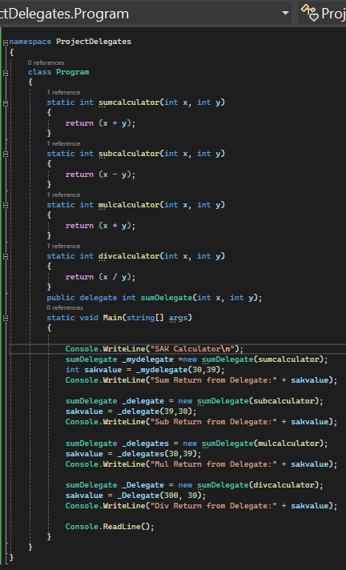
Output:
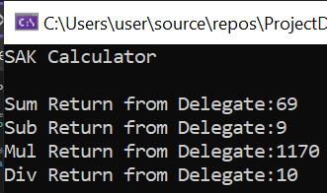

- Implementation of Loop Control Statement In C#:
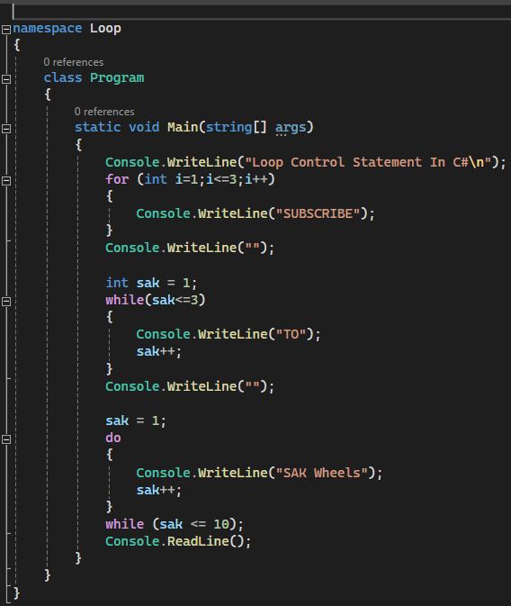

Output:
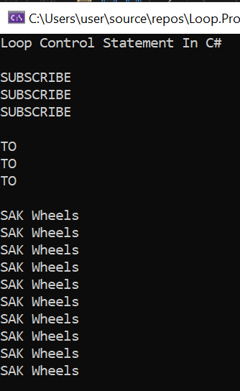

- Discussion:
Delegates are a fundamental concept in many programming languages, especially in those that support functional programming paradigms or have a need for callbacks or event handling mechanisms. They enable the passing of methods as parameters, storing them in data structures, and invoking them dynamically. This flexibility is especially useful in scenarios where you might want to change behavior at runtime or create reusable and modular code.

For instance, in C#, delegates are used as type-safe function pointers that allow defining and referencing methods. They are pivotal in implementing events, providing a way to subscribe to and handle events raised by objects.

- Conclusion:
Delegates in C# empower flexible event-driven programming, offering type-safe function pointers and enabling robust event handling mechanisms. Understanding their syntax and application enhances the modularity and efficiency of C# applications.

